Test Report For GreenITCo Website:
- Execution Date: October 10, 2026
- Executed By: QA Engineering Team
- Target Environment: Production https://greenitco.com/
- Total Test Cases: 30
- Passed: 24
- Failed: 5 (FCP 3.7s slow load, 404 on Schedule a Call, non-interactive email text, static module cards, dummy View All link)
- Blocked: 1 (Production CRM form submission safety block)
- Overall Pass Rate: 80.0
Test Cases Excel Sheet
https://docs.google.com/spreadsheets/d/16adgq4NRXtskxIoduxQvajHQrxKKrdRE/edit?usp=sharing&ouid=105622688992676357942&rtpof=true&sd=true

Load Testing:
- Using GUI:
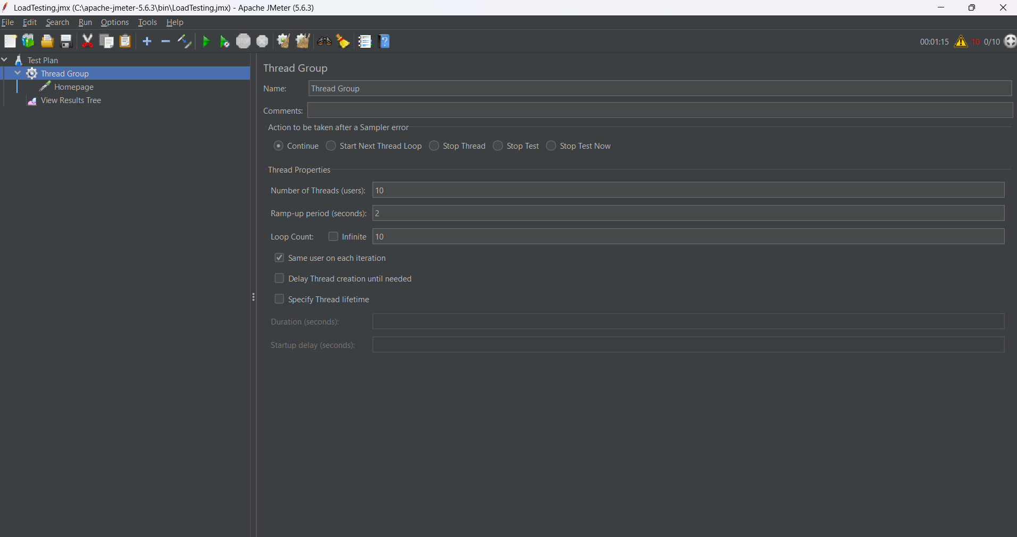
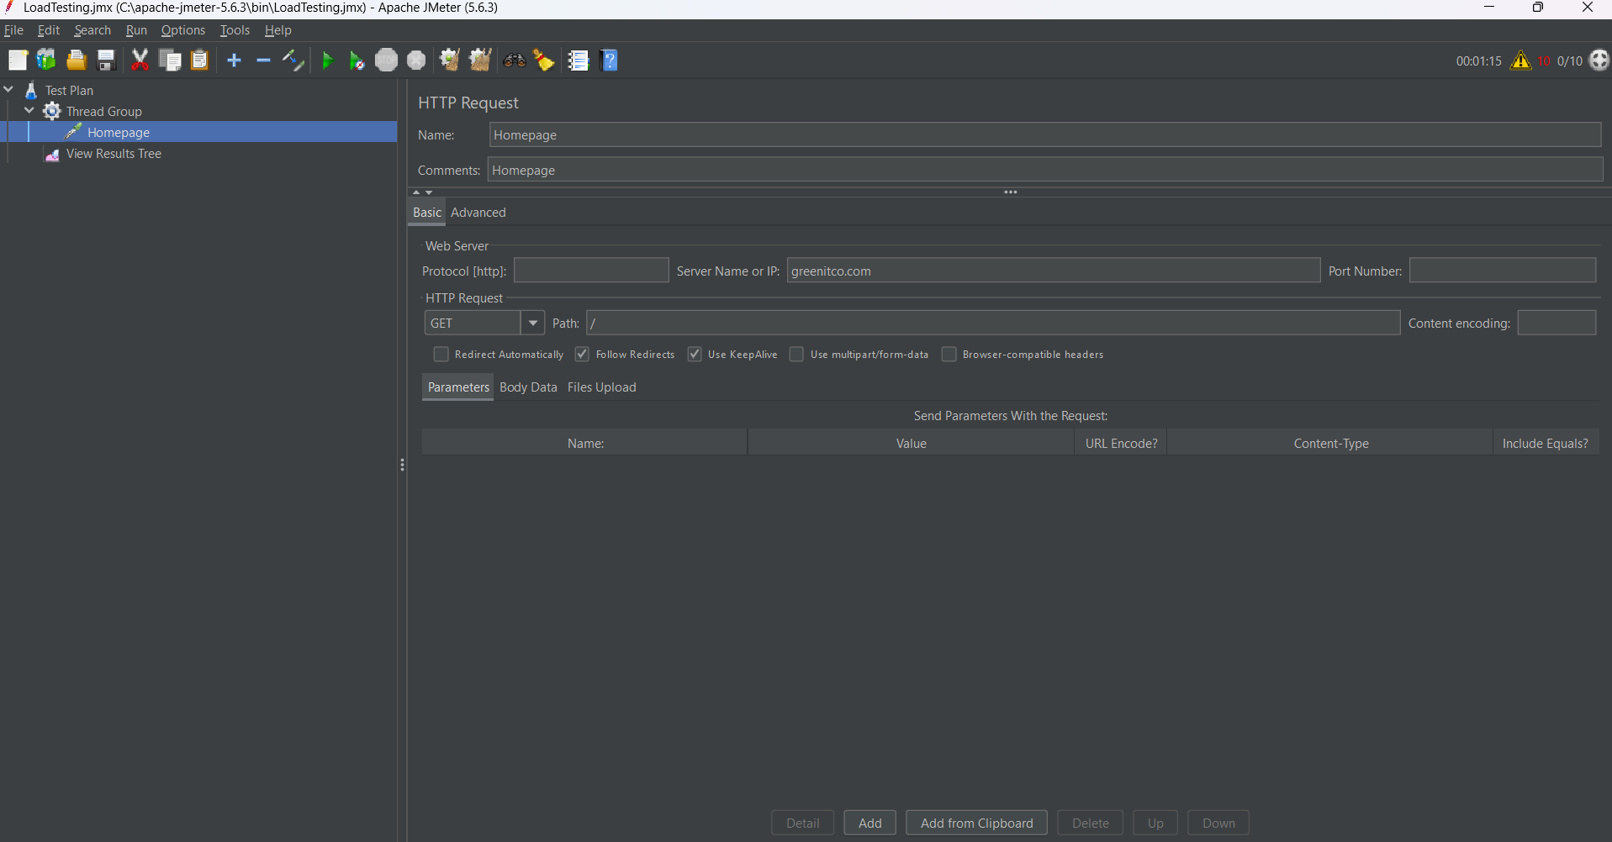
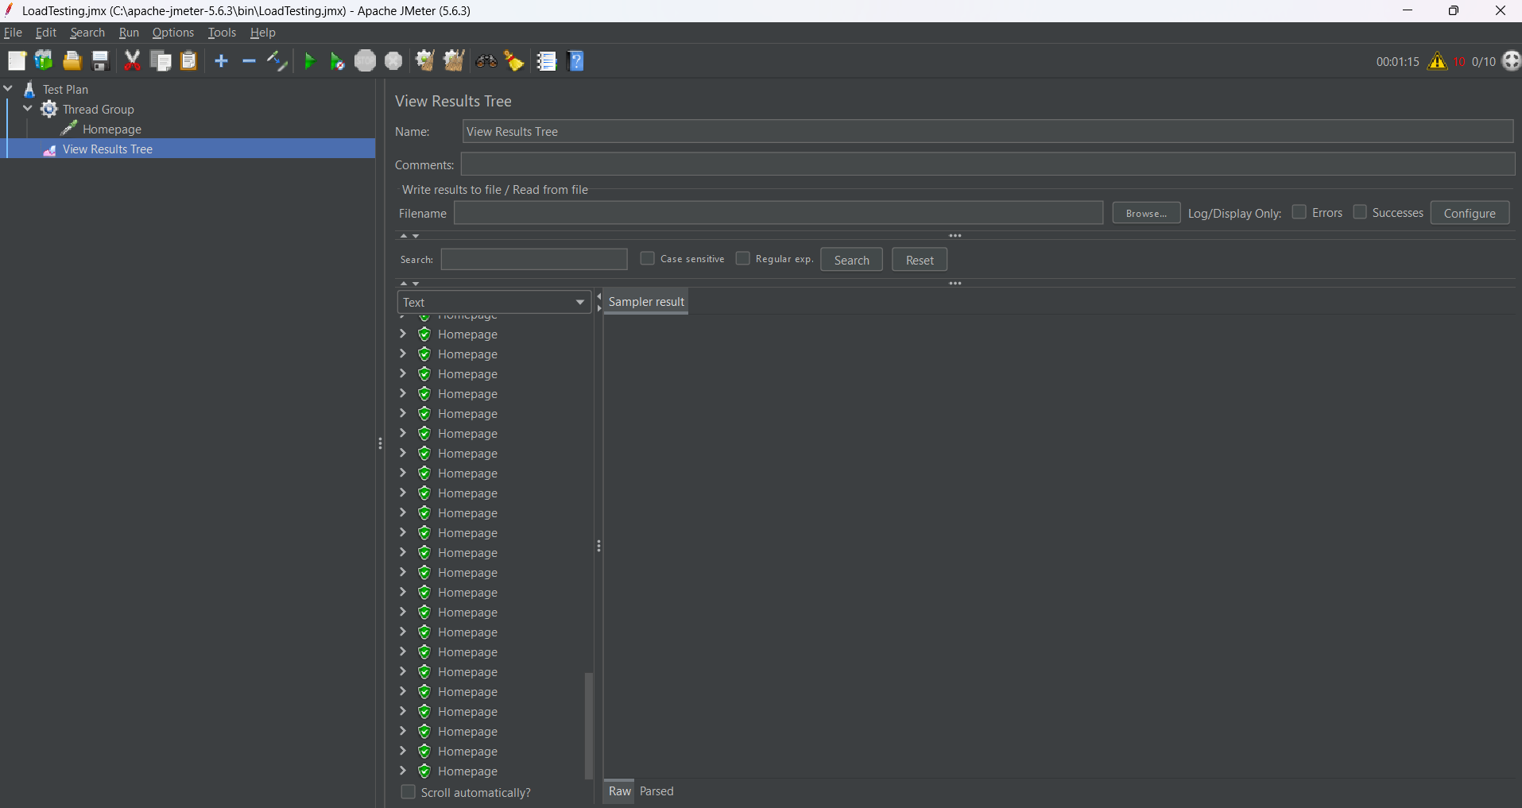
- Using cmd
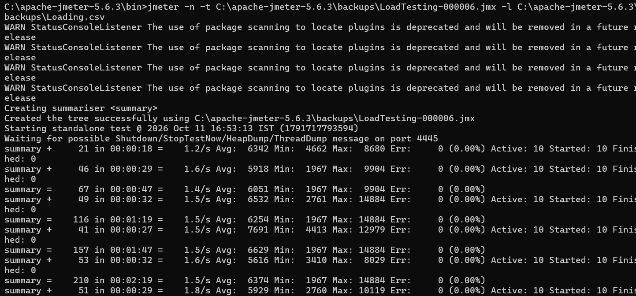

Load testing result:
https://drive.google.com/file/d/1CVLpH7PF5lWHq6dPemYsFdRFtcjwSoaC/view?usp=sharing

